**Analyzing User Emotions in Design Thinking**

**DECISION FATIGUE IN USERS**

*By*

EGHOBAMIEN UYIOGHOSA VINCENT

Vug/csc/19/3322

**A PROJECT SUBMITTED TO**

**Mr. Felix Uloko**

**May 27th**

Title page

abstract

Every user has a ‘willpower limit ‘Users experience many emotions when given many options and the power to choose, we can make a lot of decisions, but when we have so many alternatives and so many possibilities, we might make mistakes like buying goods or choosing impulsively, diminishing our capacity to trade-off, or even avoiding making a decision.

Some existing methods for reducing decision fatigue are: minimizing cognitive load with design thinking, avoiding visual clutter, Build on Existing Mental Models and Offloading Tasks. This study used Google forms questionnaires distributed within and outside of veritas university to find out what keeps users’ interest with a convenient sample size and focus group of 38, within the age of 16-130.

The questionnaire has links and screenshot to visually appealing and objectively unappealing websites, first their emotions and interests are measured with liner scale provided by google form and they are asked whether they exhibit some of the symptoms of decision fatigue, finally asked the best solution to keep their interest in the various websites. The results of the questionnaire seen that most users would very much rather have more options and take on the intrinsic cognitive load and improve navigation, color scheming of user interfaces and other methods of reducing decision fatigue etc. than to reduce their options and choices

Table of Contents

Title page i

abstract ii

Table of Contents iii

list of figures vi

list of tables vii

list of equations viii

LIST OF APPENDIX ix

CHAPTER One INTRODUCTION 1

1.1 BACKGORUND 1

1.2 PRoBLEM STATEMENT 3

1.3 RESEARCH QUESTION 3

1.4 RESEARCH AIMS AND OBJECTIVES 3

1.5 RESEARCH MOTIVATION 3

1.6 SIGNIFICANCE OF THE RESEARCH 4

1.7 DELIMITATION OF THE RESEARCH 4

1.8 OPERATIONAL DEFINITION OF TERMS 4

1.9 CHapter conclusion 4

CHAPTER Two 6

2.1 Decision fatigue and heuristic analyst forecasts 6

2.2 Intrinsic vs. Extraneous Cognitive Load 6

2.3 Minimizing Cognitive Load with design thinking 7

2.4 EMOTIONS AND FEELINGS ASSIOCATED WITH COGITIVE/DECISION FATIGUE 9

CHAPTER Three 10

3.1 RESEARCH DESIGN 10

3.2 RESEARCH TOOL 10

3.3 SAMPLING METHOD AND POPULATION 10

3.4 implementation 10

3.5 EXAMPLE OF THE FORM GIVEN TO THE FOCUS GROUP 11

3.6 USABILITY 13

CHAPTER Four 14

4.1 Results of survey 14

4.2 DISCUSSION OF FINDINGS 27

4.3 IMPLICATIONS OF FINDINGS 29

CHAPTER Five 30

5.1 KEY FINDINGS 30

5.2 LIMITATIONS 30

REFERENCES 31

CHAPTER Six Bibliography 32

list of figures

Figure 1.1 : Figure (header 5) 6

Figure 1.2 : Title Figure 6

list of equations

EQUATION 1.1 : EQUATION 1 (HEADER 6) 7

EQUATION 1.2 : Ohms Law 7

# 

# INTRODUCTION

## BACKGORUND

The term "experience" in User Experience refers to the feelings that individuals get while they utilize a product. They may be glad, satisfied, frustrated, elated, or dissatisfied by the event, depending on a variety of reasons. While using an app, a user may experience two or more emotions. (Kohli, 2019)

Emotional design is the concept of creating designs that elicit emotions, resulting in pleasant user experiences. According Don Norman (2004), Designers strive to contact individuals on three cognitive levels visceral, behavioral, and reflective so that users form only good associations (sometimes incorporating unpleasant emotions) with products, brands, and so on.

Visceral this involves Users' gut reactions to their first impressions of your design; for example, an uncluttered user interface implies simplicity of use.

Behavioral, this involves Users unconsciously judge how effortlessly and quickly your design helps them reach their goals. They should feel certain that they are in command, with minimal effort required.

Reflective, when individuals come into contact with your design, they will consciously analyze its performance and benefits, including value for money. If they are satisfied, they will continue to use it, create emotional attachments with it, and tell their friends about it. (A, 2004)

As a result, Emotional Design is concerned with developing aesthetically beautiful and practical relationships between consumers and products so that they like using the product and return to it again and again.

However, when it comes user emotions customers can be unpredictable but with design thinking UI/UX, graphic designers etc. can put themselves in the customers’ shoe. Solving problems become complex, there are many factors to consider which makes problem solving more difficult such as the user’s ego, individual knowledge, perception, beliefs, impulsive reactions and DECISION FATIGUE etc. (Rikke Friis Dam & Teo Yu Siang , 2021)

This paper is going to be focusing on decision fatigue, Currently, individuals get so much information that we can ingest in minutes or seconds, and we already have to determine so many things during the day, such as what clothes to wear, how to get to work, what food to eat, and, of course, all the decisions we make at school, work, and so on. This procedure is mentally taxing, and our capacity to make decisions suffers as a result. That is Decision Fatigue. (Débora Martins, 2019)

On some user interfaces, such as e-commerce sites, we may want to offer everything the user (thinks) desires, and in the end, we may lose him because he doesn't know what to do or which path to take.

Consider this behavior on a product or e-commerce page. It will be disastrous if you lose your sale. For example, if your product has several price alternatives, highlight the most popular ones while giving the others less visual weight.

## PRoBLEM STATEMENT

Every user has a ‘willpower limit ‘Users experience many emotions when given many options and the power to choose, we can make a lot of decisions, but when we have so many alternatives and so many possibilities, we might make mistakes like buying goods or choosing impulsively, diminishing our capacity to trade-off, or even avoiding making a decision.

## RESEARCH QUESTION

How can design thinking be used to curtail users’ decision fatigue in while simultaneously giving the user all the best options to choose from?

## RESEARCH AIMS AND OBJECTIVES

The goal of this study is to investigate the best method for engagement plans and designs that increase users’ engagement by giving users a wide range of options without causing apathy and decision fatigue.

## RESEARCH MOTIVATION

Freedom of choice is essential for every human being, as a UI/UX designer we must give our customers and users freedom to choose what their heart desires; however, since every everyone has a ‘willpower limit ‘customers can make a lot of decisions, but when we have so many alternatives and possibilities, we can make mistakes like buying products impulsively, diminishing our capacity to trade-off, or even avoiding making a decision. This can be very bad for business, for example You saw simple trousers in like ten different colors and thought, "Well, I can get the black one, but it might too hot... So perhaps this white one... Or how about this green? No, it's the grey" And you ended up buying some socks? Imagine this kind of behavior in an online site which can even cause the customer to lose interest and exit the page, it is very problematic.

## SIGNIFICANCE OF THE RESEARCH

The results of this study would be of great benefits to UI/UX designers and e-commerce sites, online catalogue, streaming services etc. by increasing customer involvement and maximizing sales by reducing fatigue.

## DELIMITATION OF THE RESEARCH

This research will center around previous literatures in design thinking and questionnaires on negative emotion, decision fatigue.

## OPERATIONAL DEFINITION OF TERMS

Decision fatigue- A term used to describe when people have made too many decisions over a specific period. Research suggests that it mainly occurs as humans’ cognitive resources diminish with time.

# 

**LITERATURE REVIEW**

## Decision fatigue and heuristic analyst forecasts

According to psychological studies, decision quality decreases after a lengthy session of decision-making, a phenomenon called as mental fatigue/decision fatigue. (DavidHirshleifer .et al, 2019)

The purpose of this study was to see if decision fatigue influences analysts' judgements. Analysts cover many companies and frequently provide multiple projections in a single day. We discover that forecast accuracy decreases throughout the course of a day as the number of forecasts given by the analyst grows. This Study also came to a conclusion that the more predictions an analyst publishes, the more likely the analyst will make heuristic decisions such as herding more closely with the consensus forecast, self-herding (i.e., reissuing their own earlier outstanding forecasts), and issuing a rounded forecast. (DavidHirshleifer .et al, 2019)

## Intrinsic vs. Extraneous Cognitive Load

According to (Kathryn Whitenton , 2013) There is no way to completely reduce cognitive stress and even if it were feasible, it would not be desirable. After all, individuals visit websites to learn more. They've come to learn more about your product, business, or content; most likely, it's something they didn't know before. The effort of absorbing new knowledge and staying on track with their own goals is referred to as intrinsic cognitive load. Designers should, on the other hand, attempt to eliminate, or at least reduce, superfluous/extraneous cognitive load: processing that consumes mental resources but does not assist users grasp the material (for example, distinct font styles that do not convey any unique meaning).

## Minimizing Cognitive Load with design thinking

Designers can emulate the common strategies in their design after empathizing with customers by:

**Avoiding visual clutter**: unnecessary links, irrelevant images, and meaningless typography all slow down users. (It should be noted that useful links, graphics, and typography are all valuable design elements; it is only when they are overused that they become ineffective.) (Kathryn Whitenton , 2013)

**Build On Existing Mental Models**: individuals already have mental models of how websites work based on their previous visits to other websites. You limit the amount of learning users need to perform on your site by using labels and layouts that they've seen on other websites.

**Offloading Tasks**: Examine your design for anything that requires users to read content, recall information, or make a decision. Then consider your options: can you display a picture, re-display previously submitted data, or establish a sensible default? You won't be able to remove all chores from users' hands, but every task removed frees up brain resources for decisions that genuinely matter. (Kathryn Whitenton , 2013).

**Navigate Using Visual Cues.**

The heart of any website, user interface or app is its navigation. It is what makes your design functional and accessible to everyone. It can be difficult to discover a good navigation system for your specific use case, but it is critical for the user experience. A terrible one is irritating and distracting, resulting in a negative overall experience. (Rådahl, 2021)

**Minimizing the number of choices users have to make**

When users have the option of too many choices, they are bound to get agitated, confused or frustrated. A product can have all of the features in the world, but when the interface is too convoluted because of this overabundance of choice, it does not end up being user-friendly. A study from the Journal of Personality and Social Psychology (Rust,et.al 2006) found that this often causes decision paralysis and frustration when we have too many options. (Rådahl, 2021).

Because cognitive ability is limited, expanding possibilities may result in decision fatigue (Mathew & Joseph, 2014; Olsen 2015). As a result, it might be argued that reducing the number of possibilities would be advantageous in order to avoid decision fatigue. • Too much product information on e-commerce websites might lead to choice fatigue (Mathew & Joseph, 2014). When there is a lot of information, making a decision can be difficult, resulting in a depletion of mental resources. When mental resources are depleted, bargaining power is decreased, the likelihood of making the correct decision lowers, satisfaction falls, and greater regrets may be felt as a result of the choices made. • In the realm of informatics, Dubbey (2019) conducted research on critical thinking, e-learning, and decision fatigue.

## EMOTIONS AND FEELINGS ASSIOCATED WITH COGITIVE/DECISION FATIGUE

In this article (Berg, 2021) she discussed with AMA (Against Medical advice) member Lisa MacLean, MD, discusses what patients should know about decision fatigue. Dr. MacLean is a psychiatrist and the chief wellness officer at Henry Ford Health System, a participant in the AMA Health System Program.

According to Dr. MacLean. “The more options you have, the more it can wear on your brain, and it may cause your brain to look for shortcuts," she continued, noting that "there are four main symptoms: procrastination, impulsivity, avoidance, and indecision. “In other words, decision fatigue saps individuals’ energy

.

# 

**RESEARCH METHOD**

## RESEARCH DESIGN

Research was designed to answer the research question and objectives stated in chapter one, which are mainly to discover the best method to curtail decision fatigue. The questionnaires contain both quantitative and qualitative questions

## RESEARCH TOOL

Questionnaire development

The questionnaire was developed in four phases. In the first phase, the scientific

literature on the construct of decision making was comprehensively reviewed by

Questionnaire development

The questionnaire was developed in four phases. In the first phase, the scientific

literature on the construct of decision making was comprehensively reviewed by

The major tool used for this research was google forms

## SAMPLING METHOD AND POPULATION

Convenience sampling method was used based on the individuals at my disposal from ages 16-50 within and outside veritas university. The size of my focus group used was 36 people

## implementation

The questionnaire was divided into two parts, using well-known website such as [ARNGEN.net](https://www.arngren.net/)  , <http://www.gatesnfences.com/>, <https://www.gordonwaynewatts.com/> with an ugly user interface that cause negative emotions and likely cognitive fatigue to its users due to its interface and using known visually appealing websites such as sassiholford.com, jumia.ng, Netflix library interfaces that are seen as appealing to measure the emotions felt by the users.

Measuring induvial emotions and interest with the linear scale provided by google forms and recognizable symptoms listed in my literature review that occurred with decision fatigue. At the end of the questionnaire, individuals were given options that included suggestions to reduce cognitive demand which were listed in chapter two(literature review) through the interface design

## EXAMPLE OF THE FORM GIVEN TO THE FOCUS GROUP

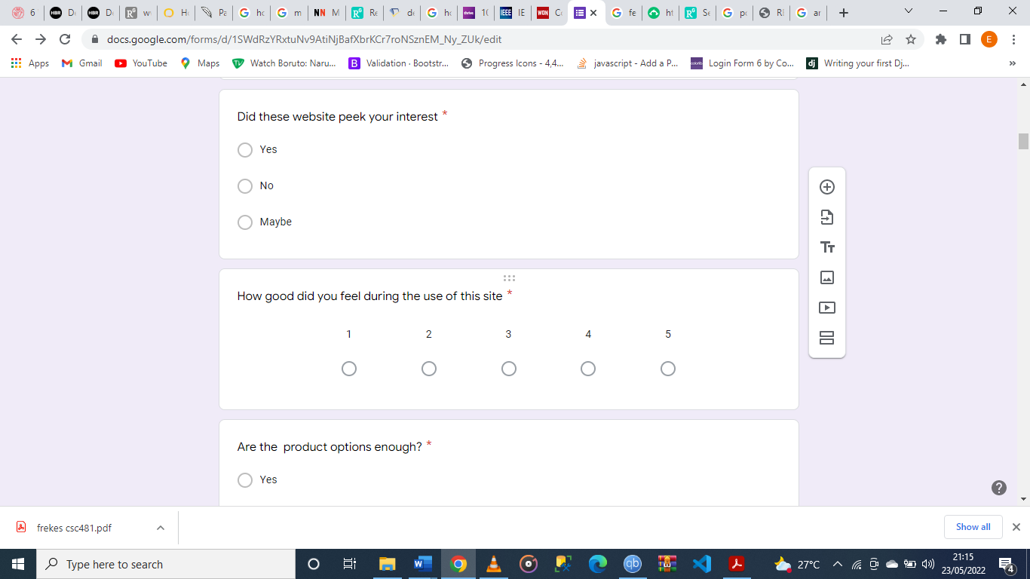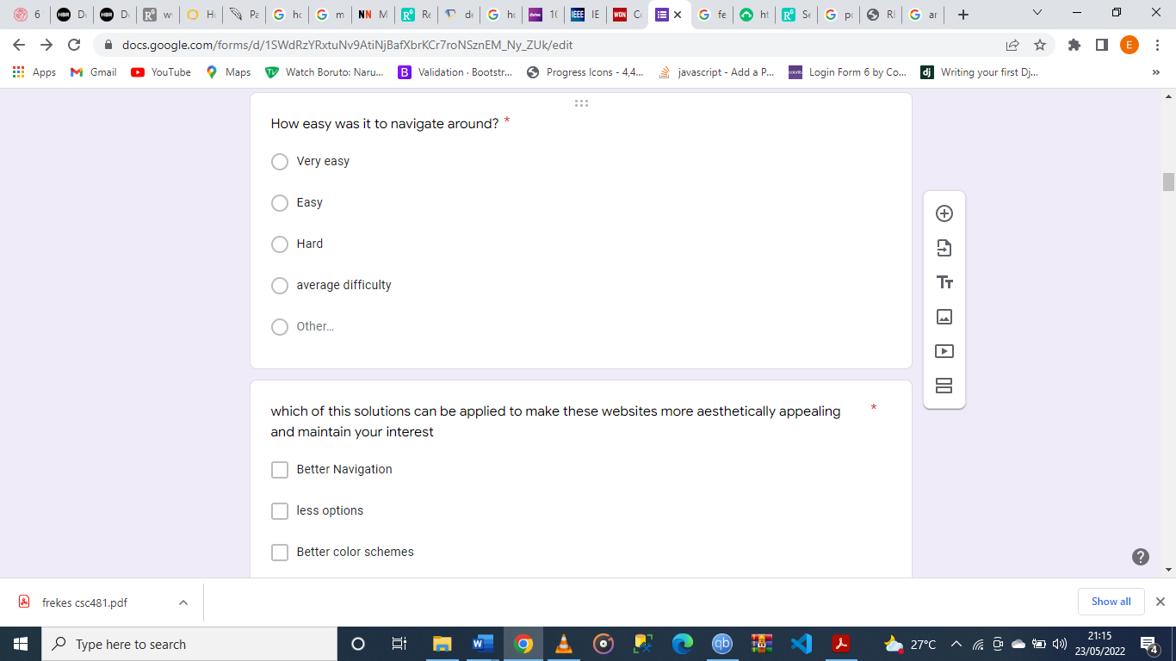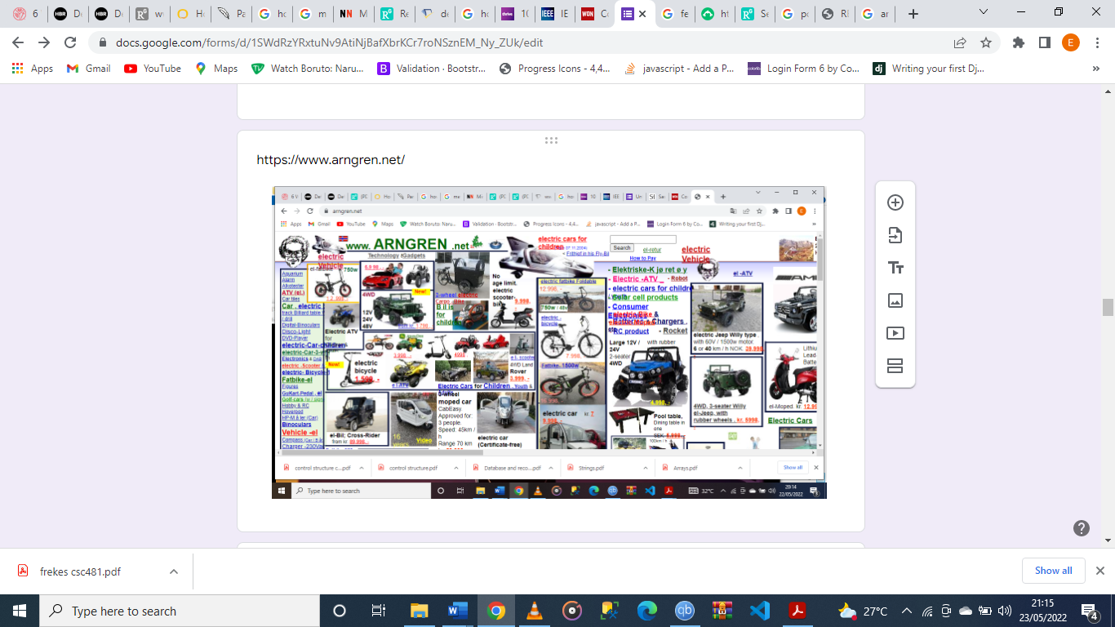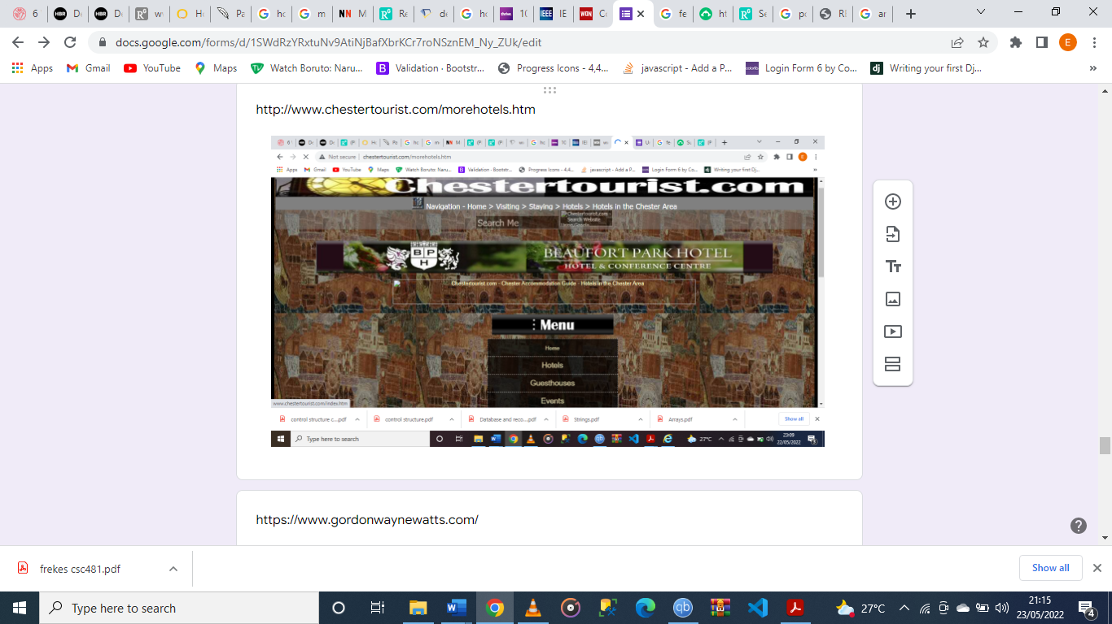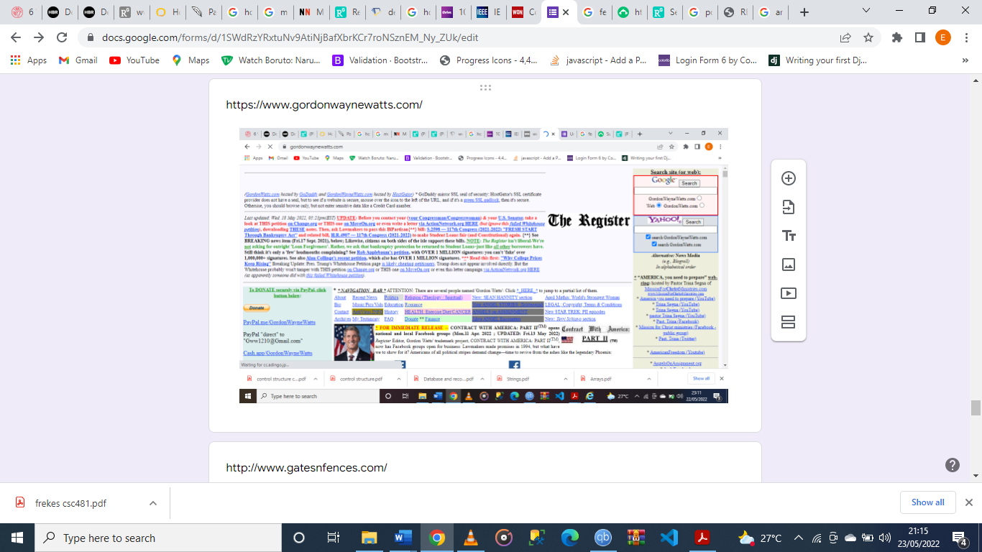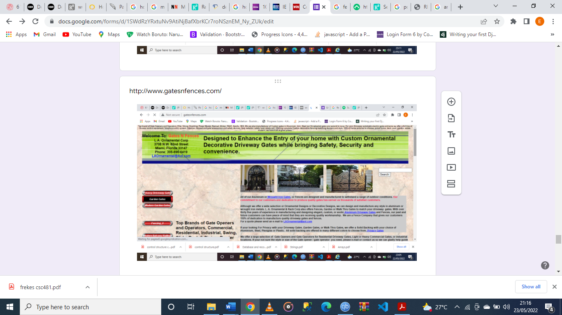

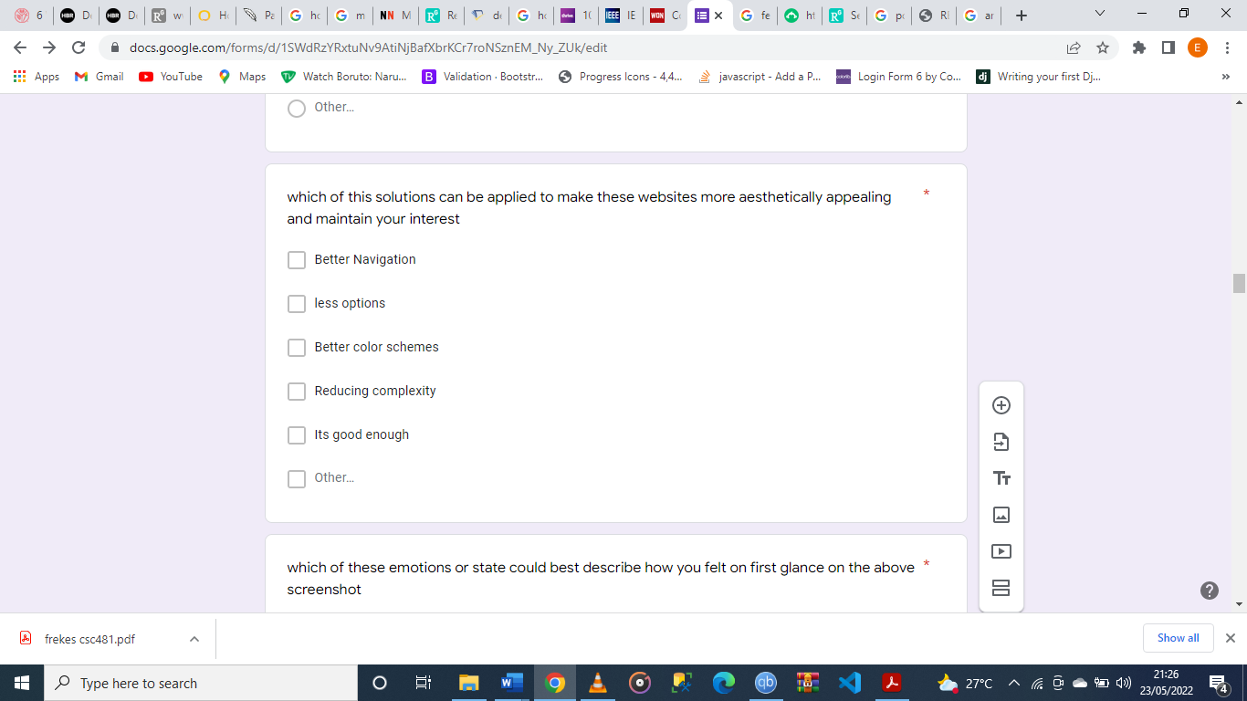

## USABILITY

Survey was made as clear as possible to reach my goal

# 

## Results of survey

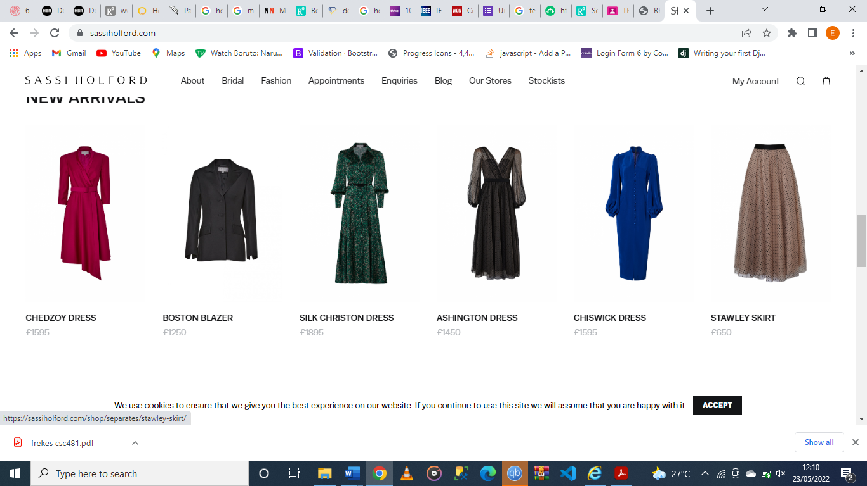

**FIG1 SCREENSHOT SASSIHOLFORD.COM**

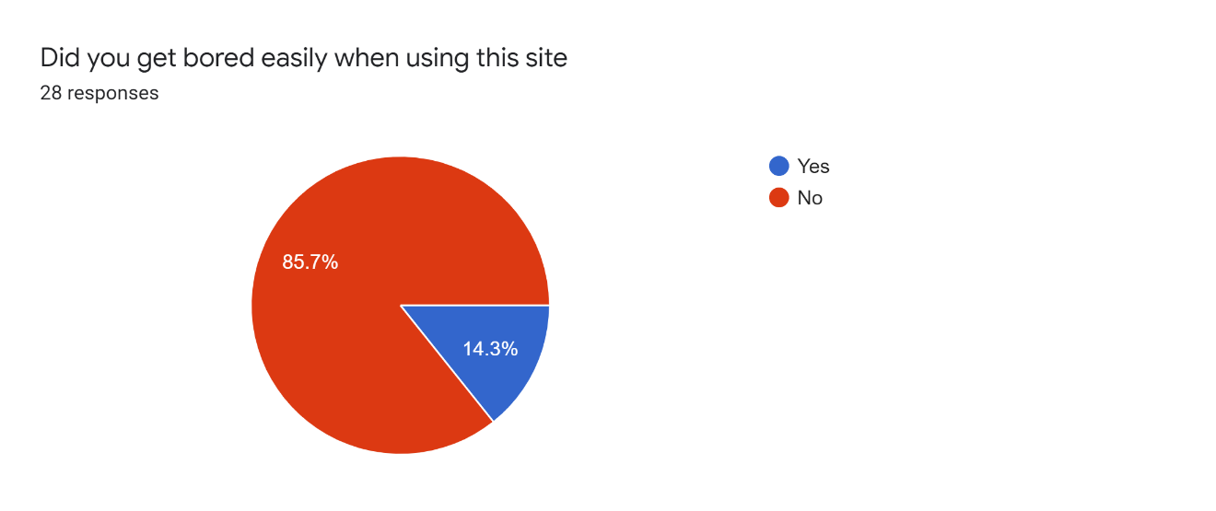

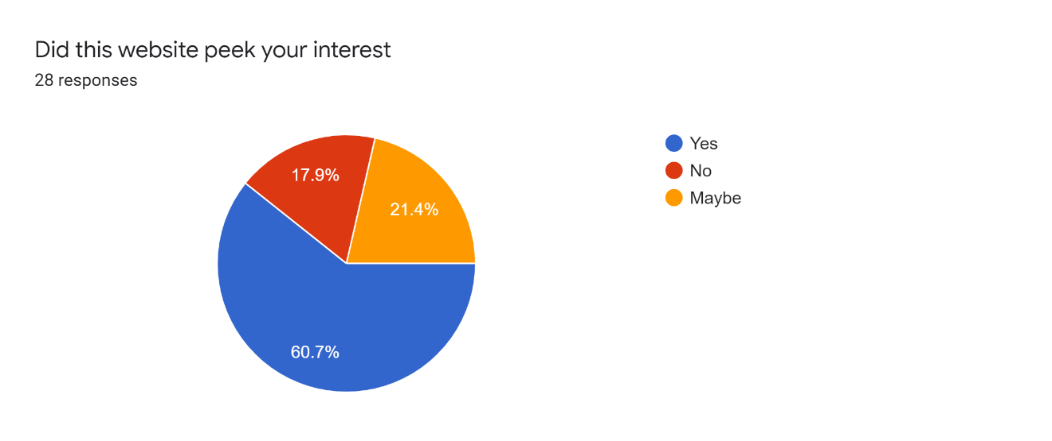

INTEREST RATE OF SASSIHOLFORD

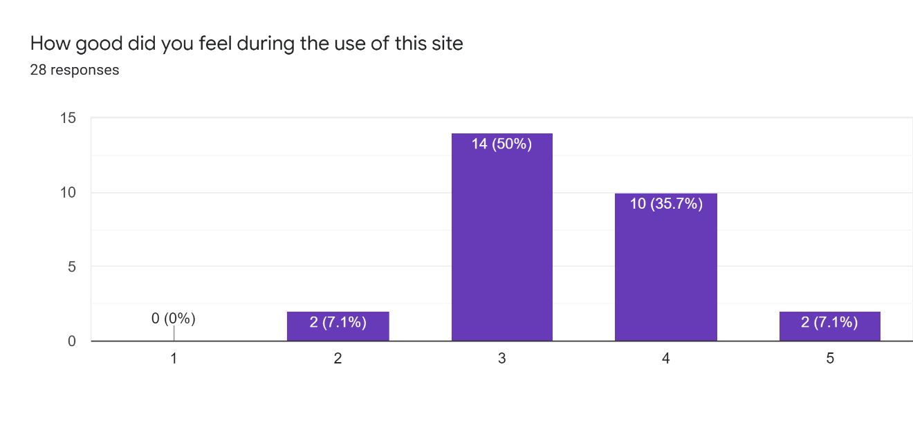

ON A SCALE OF 1 TO 5

ON A SCALE OF 1 TO 5

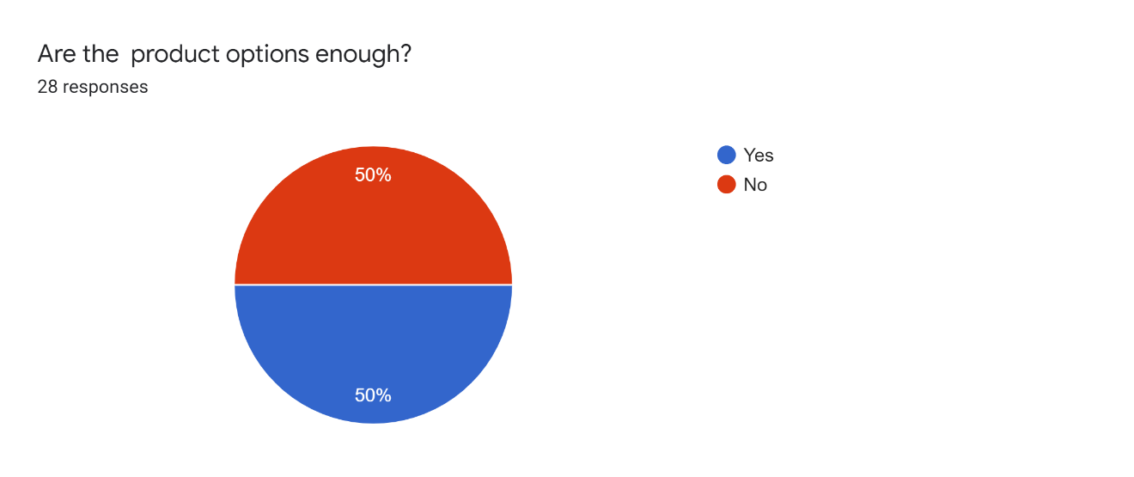

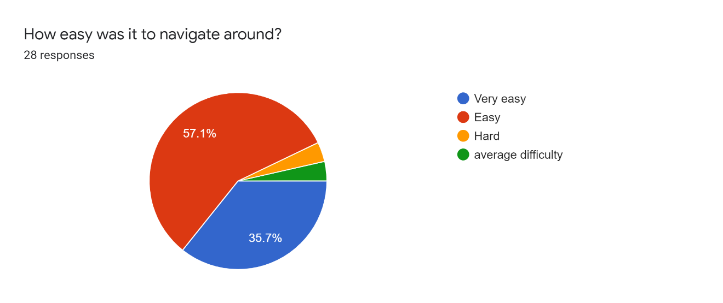

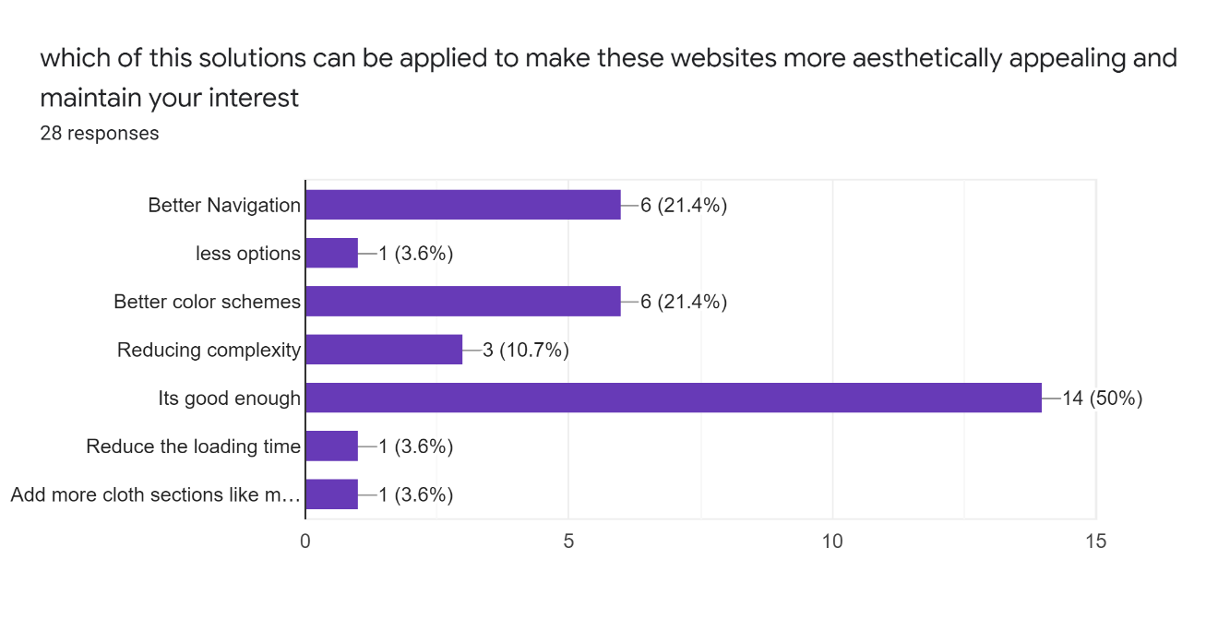

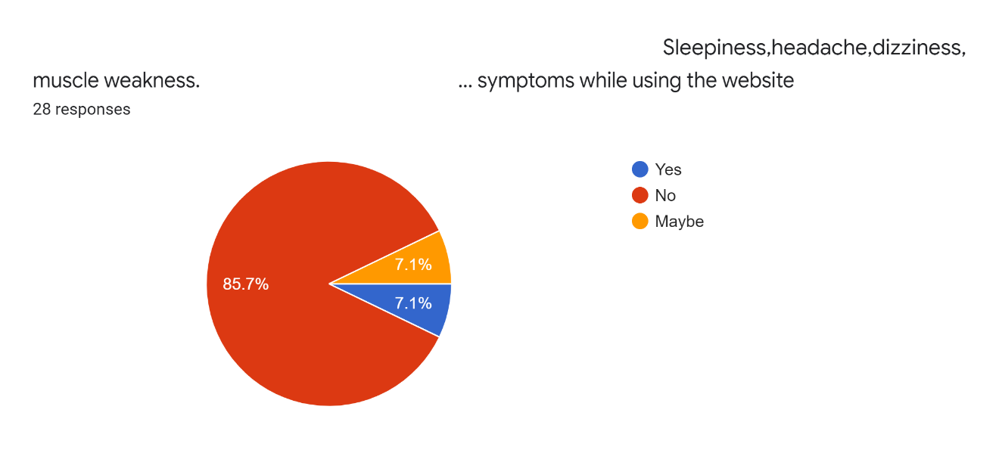

Symptoms experienced when using sassiholford.com

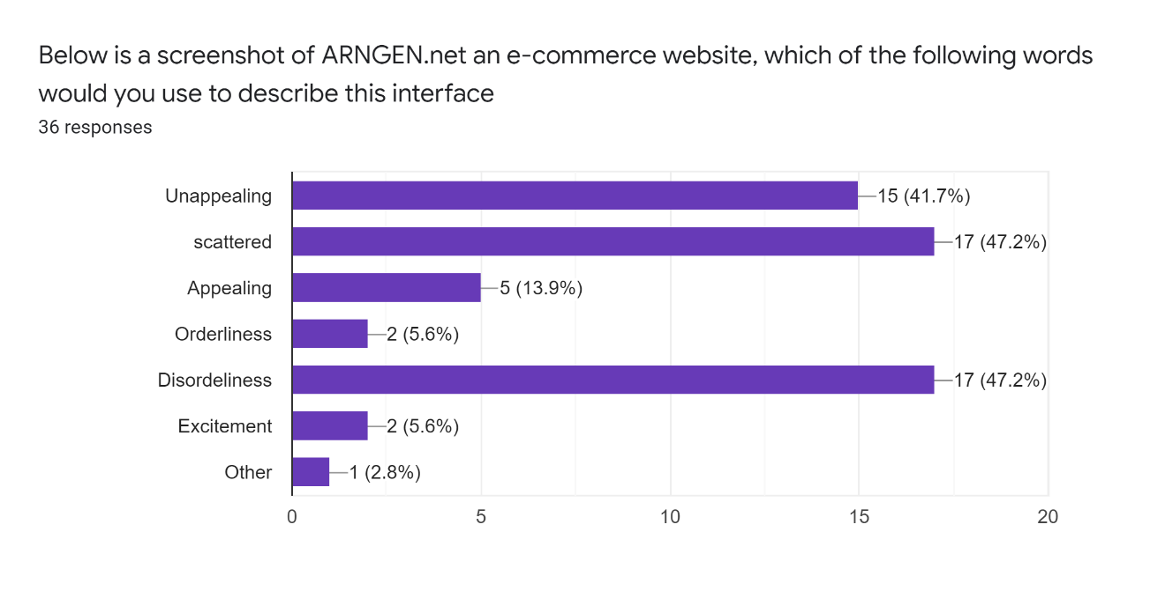

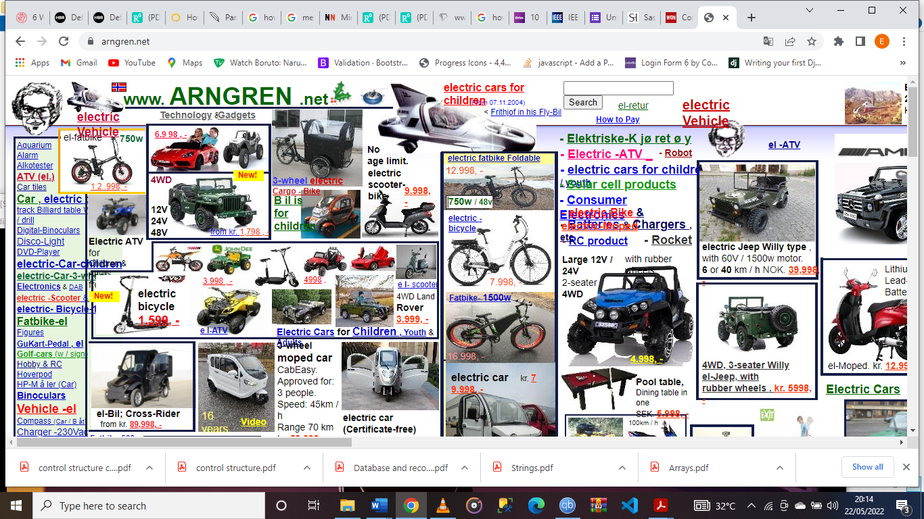

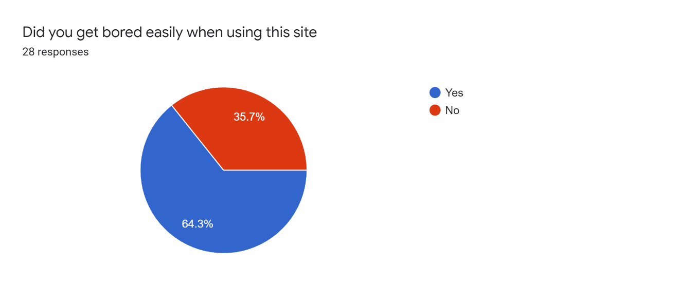

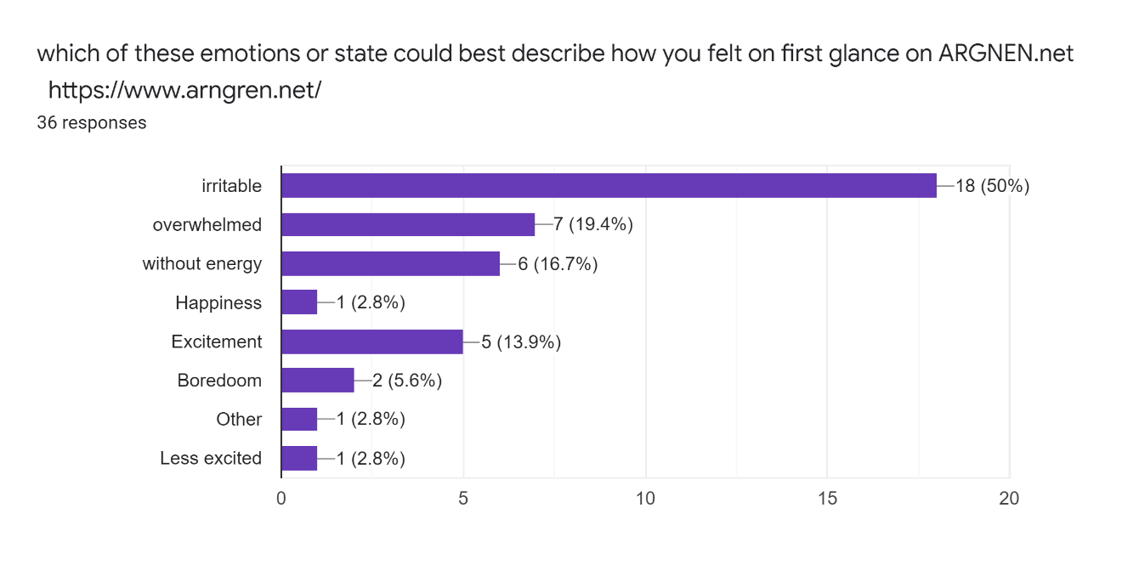

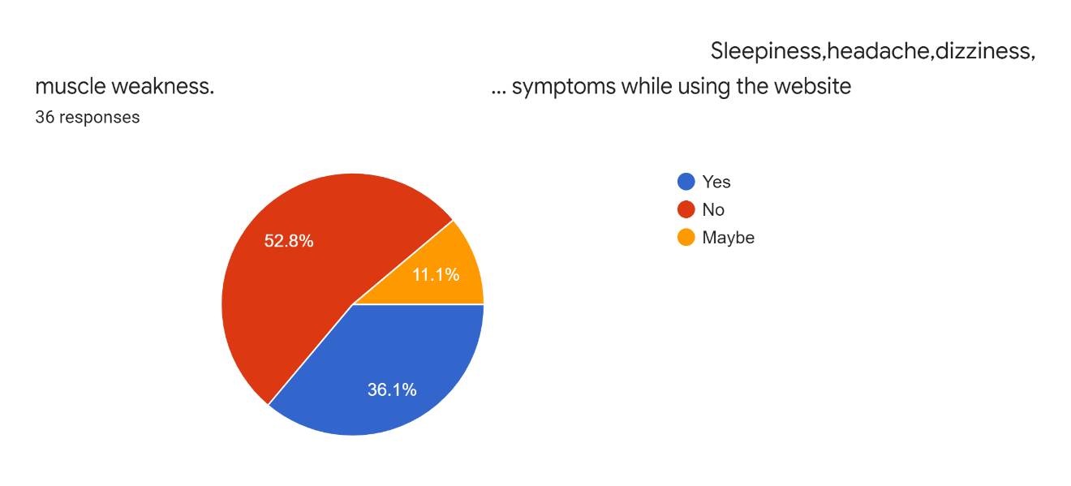

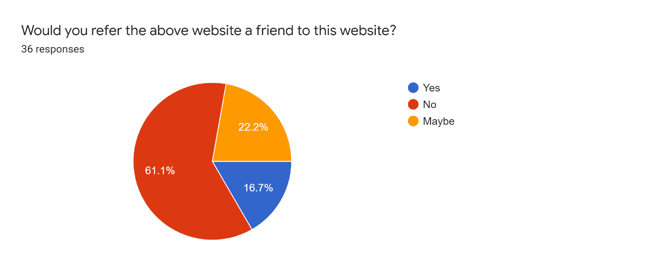

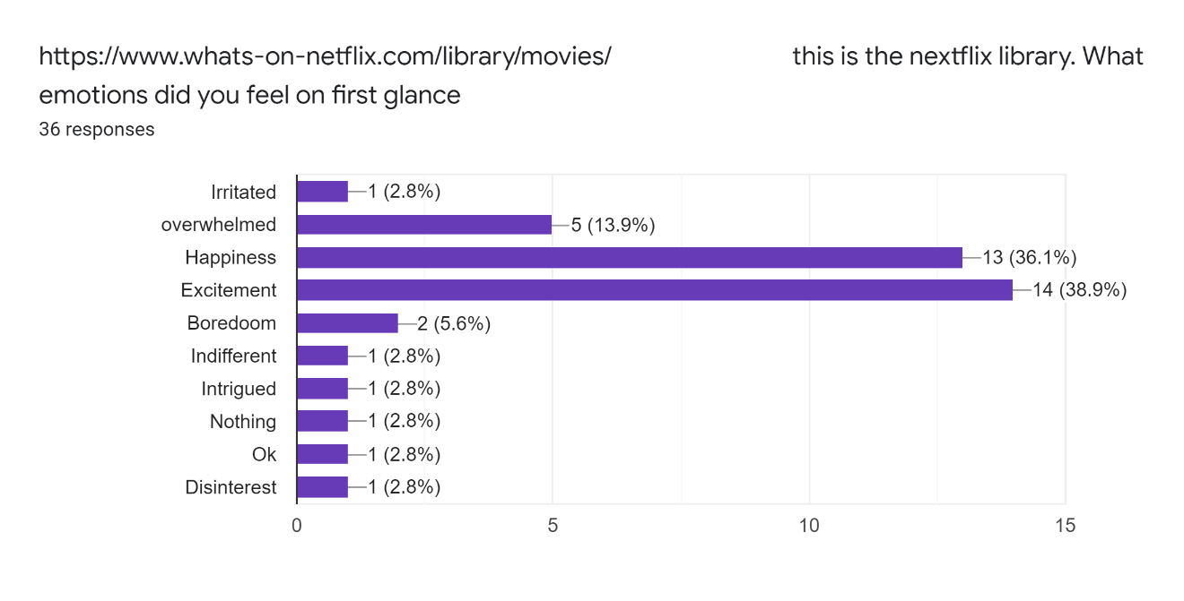

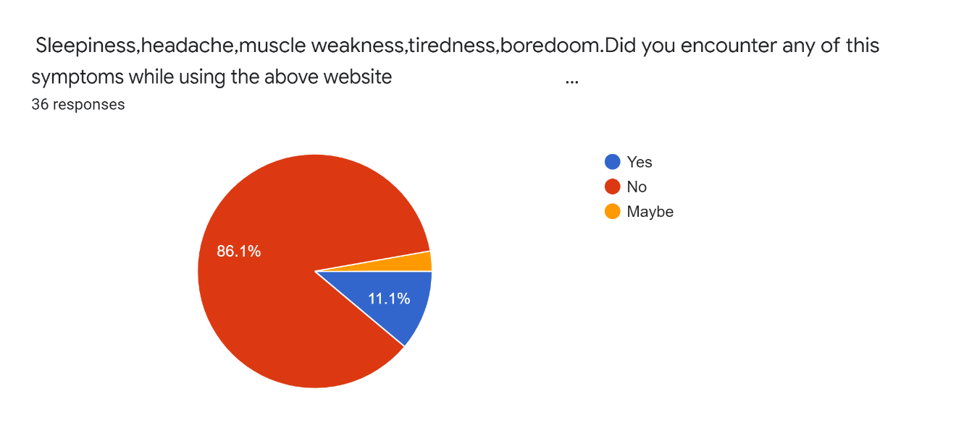

SYMPTOMS FROM USING NEFLIX LIBRARY

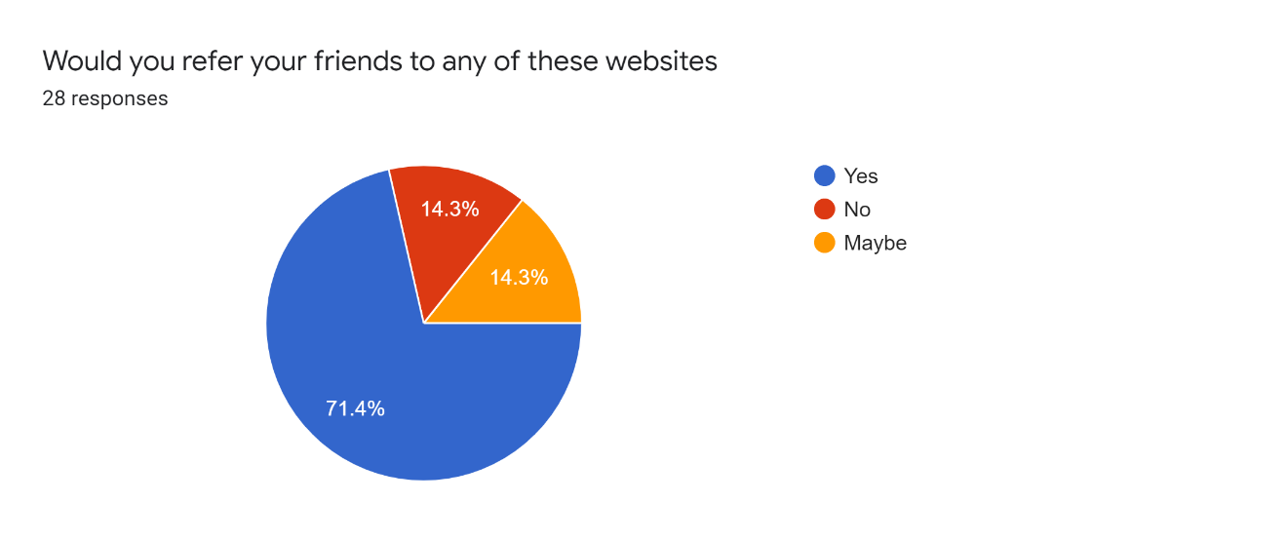

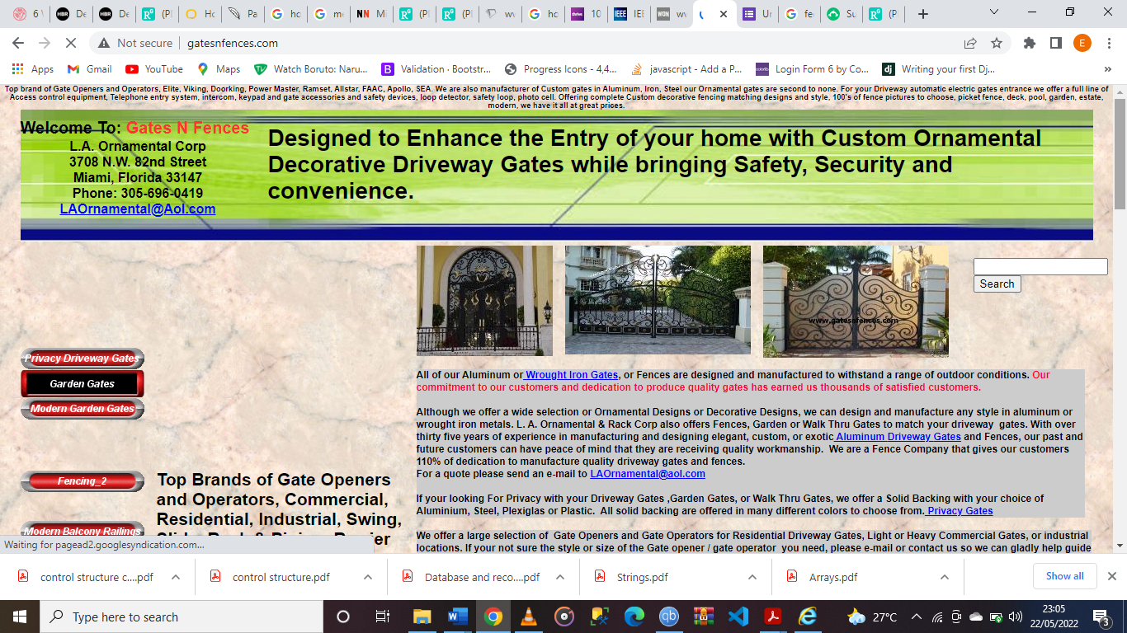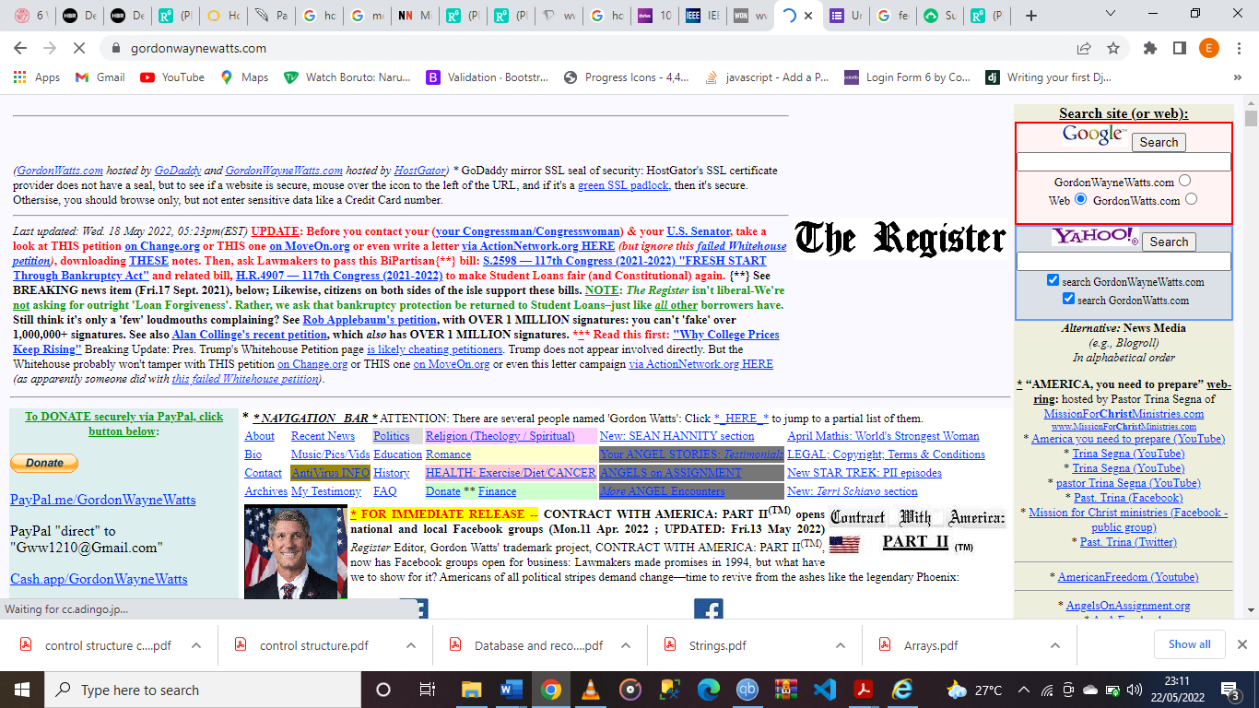

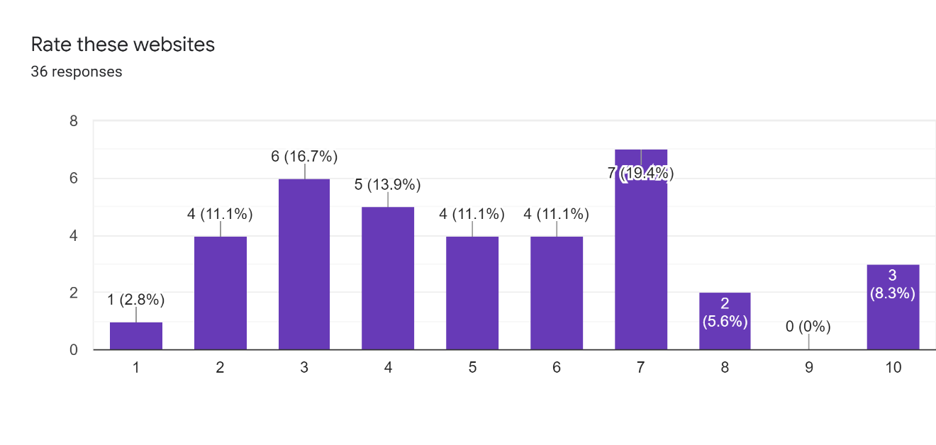

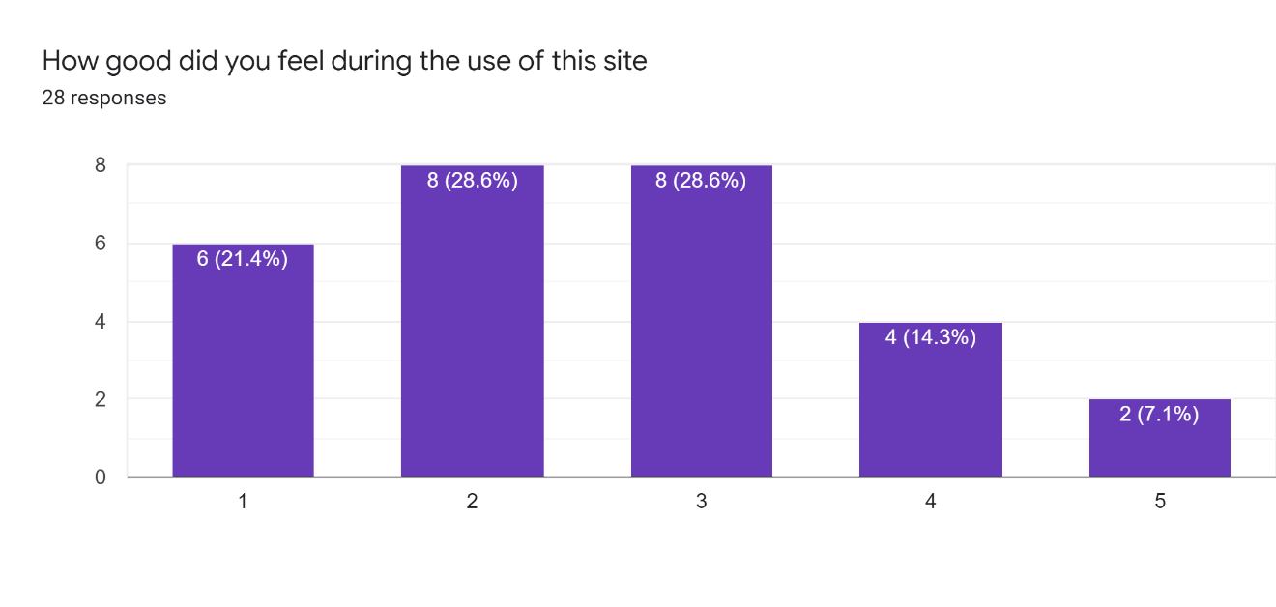

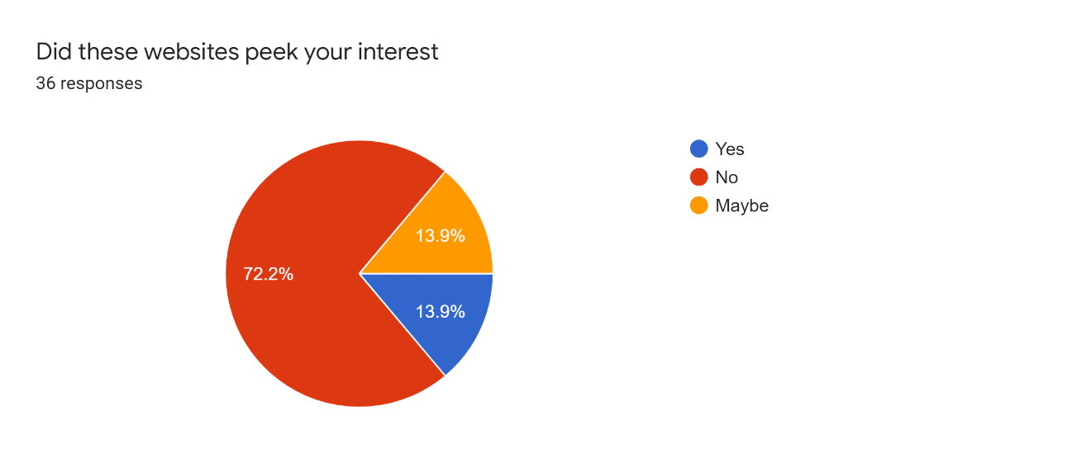

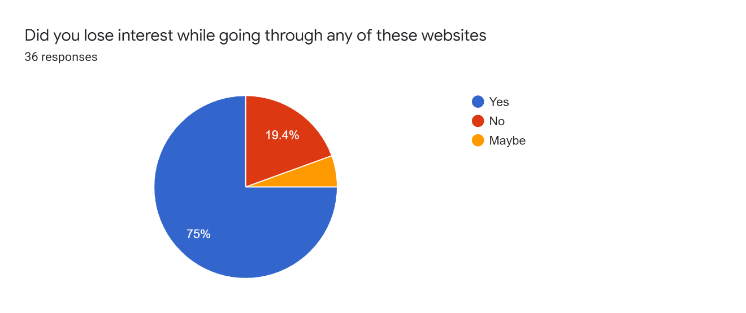

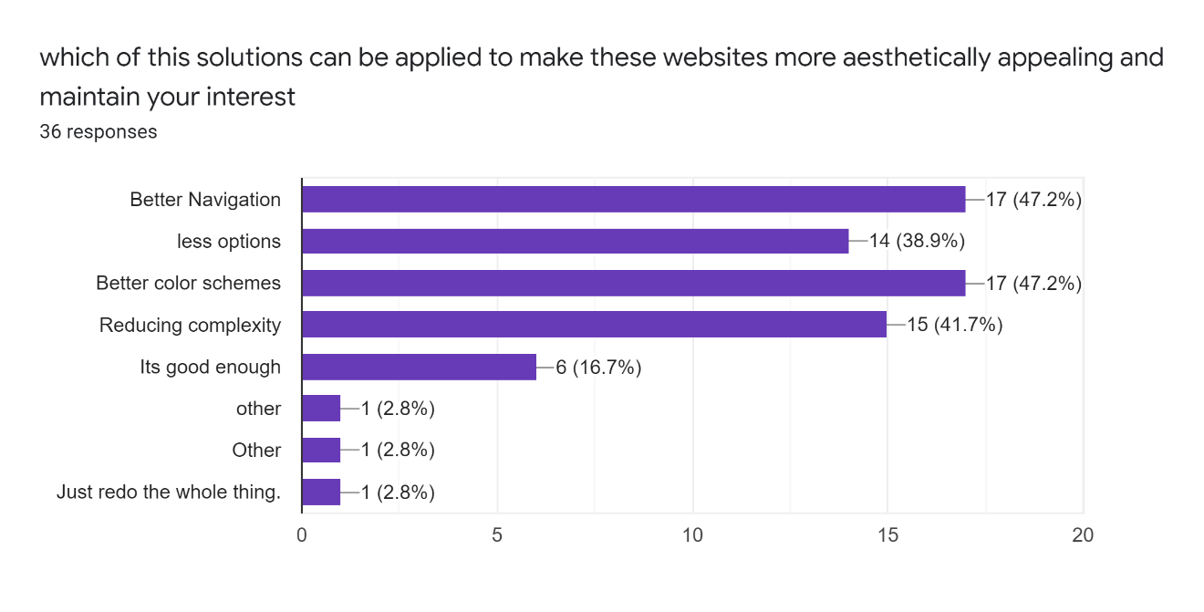

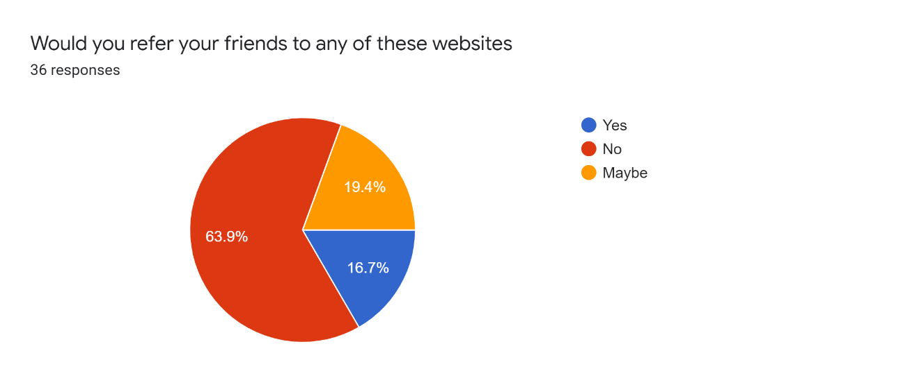



## DISCUSSION OF FINDINGS

This is the link of the full results of the questionnaire

<https://docs.google.com/forms/d/1SWdRzYRxtuNv9AtiNjBafXbrKCr7roNSznEM_Ny_ZUk/edit?usp=sharing>

From the results obtained we can see that user interface highly influenced users’ interest and cognitive load. Users interest rate is rather high when using sassiholford.com, a well-designed e-commerce website with a good UI. The website peeked users’ interest, https://www.sassiholford.com/ and https://www.whats-on-netflix.com/library/movies/ Netflix library made users feel good the most and users had less emotions and feelings attached to decision fatigue, these emotions are mentioned in my literature review.

When giving solutions to make the user interface better, the results showed that 48.3% of the users were satisfied with the UI,20.7% chose better navigation,3.4%.chose less options

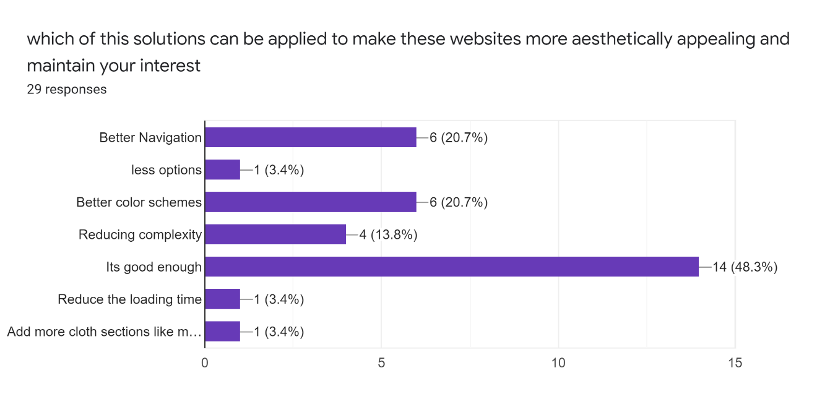

When looking at the responses to the websites in section 3, we see lower rating and symptoms of decision fatigue when users are made to <http://www.chestertourist.com/morehotels.htm/> <https://www.gordonwaynewatts.com/>

<http://www.gatesnfences.com/> websites within the same time gap, they cause more of extraneous cognitive load than intrinsic. <http://www.ARNGEN.net/> is seen to have a very low referral rate and causes negative emotions from users



Out of the 6 highlighted methods of reducing decision fatigue /cognitve demand (Rådahl, 2021) in the 3 websites above,to improve user experience and get positive emotions it is seen that the most chosen solution is to improve navigation and better color schemes,followed by reducing complexity because at theend of the day users still want to be accessible to as many options as is available



## IMPLICATIONS OF FINDINGS

From the results of the survey, we see that better navigation is the best method of curtailing decision fatigue because no matter how aesthetically unappealing a UI is users always want more options. This means that websites should focus on giving users more options with better navigation, color schemes etc. because at the end of the day users would prefer more options

# 

## KEY FINDINGS

To conclude the research paper, we see that better navigation and color schemes reduce occurrence of symptoms of cognitive load when using websites while maximizing profit by giving users more options

## LIMITATIONS

The major limitation of this paper was low population in the sample size and sampling was chosen based on convenience. Also didn’t have enough time due to school and other courses

# REFERNCES

A, N. D. (2004).

Berg, S. (2021, Novemeber 19). *ama-assn.org/*. Retrieved from What doctors wish patients knew about decision fatigue: https://www.ama-assn.org/delivering-care/public-health/what-doctors-wish-patients-knew-about-decision-fatigue#:~:text=Decision%20fatigue%20leaves%20you%20drained,-%E2%80%9CA%20person%20with&text=%E2%80%9CThe%20more%20choices%20you%20have,impulsivity%2C%20

DavidHirshleifer, YaronLevi , BenLourie, & Siew HongTeoh. (2019, july , ). Decision fatigue and heuristic analyst forecasts. *Journal of Financial Economics, 33*( 1 ), 83-98. Retrieved from https://www.sciencedirect.com/science/article/pii/S0304405X19300054?casa_token=PnCr6YzhK_YAAAAA:mYXMt_I2_RvMnnE2EulnJypQKjU4iWkzAhGy5KkDP9W4cMpUfmtlFIfZlLKf27137InDXz6TFBI

Débora Martins. (2019, january). *Decision fatigue and user experience*. Retrieved from uxdesign.cc: https://uxdesign.cc/decision-fatigue-and-user-experience-d9270bf29400

Kathryn Whitenton . (2013, December 22). *Minimize Cognitive Load to Maximize Usability*. doi:https://www.nngroup.com/articles/minimize-cognitive-load/

Kohli, T. (2019, november 25). *The why and how of emotional design*. Retrieved from uxplanet.org: https://uxplanet.org/the-why-and-how-of-emotional-design-3a51d56b84a1

Rådahl, A. (2021). *radahl.no*. Retrieved from 6 Ways to Reduce Cognitive Demand When Designing UX: https://radahl.no/6-ways-to-reduce-cognitive-demand-when-designing-ux-5571bad05b2f/

Rikke Friis Dam, & Teo Yu Siang . (2021). *Obstacles to Problem Solving and Innovation in Design Thinking*. Retrieved from interaction-design.org: https://www.interaction-design.org/literature/article/obstacles-to-problem-solving-and-innovation-in-design-thinking

Rust, R. T., Thompson, D. V., & Rebecca. (2006, february). Defeating Feature Fatigue. *Journal of Personality and Social Psychology* . Retrieved from https://hbr.org/2006/02/defeating-feature-fatigue